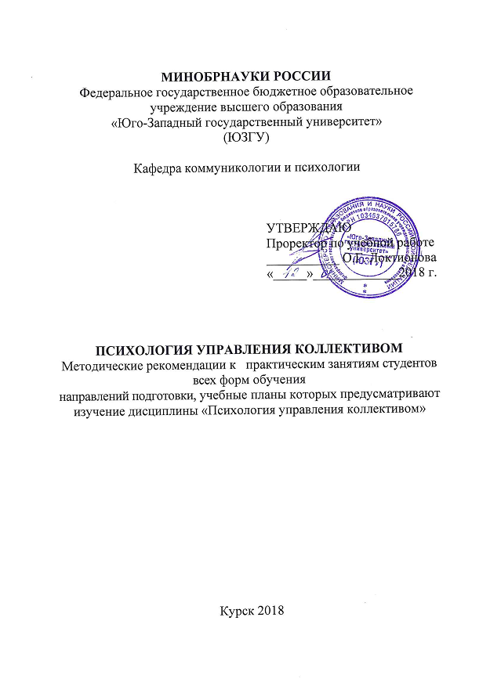

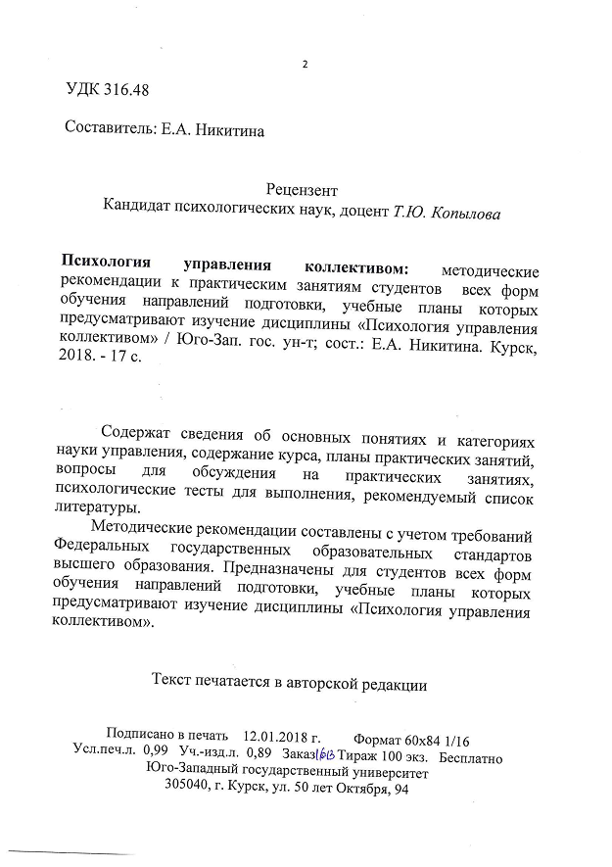

Foreword

Guidelines are designed for students of all forms of education of training courses, training plans which include the study of discipline "team management psychology"With a view to the efficient organization of workshops on the subject.
Guidelines were developed in accordance with the curriculum of training courses that provide for the studychenie discipline "team management psychology".
The purpose of discipline - formirovanie holistic understanding of the psychological foundations of management, as well as the formation of a common psychological and administrative culture of students as an essential component of professional and cultural training specialist.
discipline tasks:
- acquaintance with the history and the basic directions of development of modern psychological science and management;
- mastering the conceptual apparatus describing the administrative activity and its psychological aspects;
- understanding of basic information on the problems of formation of professionally important qualities of a leader, building a psychologically competent managerial influence, management of social and psychological climate of the organization and group processes in it;
- improve the culture of the business relationship, acquaintance with the basics of organizational structure, the methods of efficient organization of business communication and professional management activities;
- familiarization with the methods of the impact of the head on the subordinates and the organization as a whole, as well as the methods of self-development and self-education;
- the acquisition of professional experience in the analysis of problematic situations, taking into account individual psychological and personality characteristics of people.

Methodical instructions for students
for the development of the discipline

The main types of classroom work students are lectures and practical work.
During the lectures the teacher presents and explains the basic, the most difficult concepts of the theme, as well as the related theoretical and practical problems, provides recommendations on practical training and guidance for independent work.
Practical work complete study of the most important topics of the discipline. They serve to consolidate the material studied, skills development and report preparation skills, communications, oral gain experience of public speaking, of debate, argument and defense put forward positions, as well as to control the degree of readiness of the teacher of students in the study discipline.
Practical work involves the free exchange of views on selected topics. The lesson begins with an introduction of the teacher, formulating the purpose of the activity and is characterized by its main themes. Then, as a rule, students heard the message. Posts Discussion combined with the consideration of the issues identified. Posts involving the analysis of publications on specific issues of the seminar, usually heard in the middle of class. Encouraged the nomination and discussion of alternative views. In closing remarks, the teacher leads the discussion and announce the scores serving students. In order to control the preparedness of students and give them the skills brief written statement of the thoughts teacher during practical training may carry out the current control of knowledge in the form of tests.
In preparation for the lesson, students have the opportunity to take advantage of advice from the instructor. In addition to these topics, students may, in consultation with the teacher, to vote and other topics of interest.
The quality of academic work of students in the teacher evaluates the end of the session.
With the development of the course, the student can use the library of the university, which are fully provided with relevant literature.
In preparing these guidelines should guide the student to offset:
- you must seek to understand all the material before the exam to do but obscure issues;
- is necessary to strictly monitor the accuracy of their statements and the correctness of the terms used;
- should not be afraid of additional questions - often the teacher is using them as a way to help the student or to save time;
- before you answer a question, you must first understand it correctly.

Topics and content of practical training

Topic 1. Theoretical basis of management psychology.

1.MANAGING as a socio - psychological phenomenon.
2.Ponyatie of management psychology, its object and subject.
3. Stages of management science. Key management culture.

Issues for discussion:What are the prerequisites of management science? What are the advantages and disadvantages of management cultures, you can highlight? At what stage of management culture began to apply the most effective methods of management?

Theme 2. The identity manager.

1.Rukovodstvo and leadership.
2. Main functions of management activities and their psychological characteristics.
Leadership 3.Teorii.
4.Professionalno important leadership qualities. Leadership styles.

Issues for discussion:The different formal and informal leaders? Could there be some leaders in the group? What does the leader of the group? What qualities should a person to become a leader? Is it possible option combining formal leader and the leader in one person?

Theme 3 Personality slave as a control object

1.Trebovaniya subordinate to the individual.
2.Konstruktivny and destructive types of subordinate. 3.Individualno - psychological characteristics of subordinates. 4..Adaptatsiya, business roles and positions of members of the organization.

Issues for discussion: What are the challenges of working with the head of a destructive type of slave? Should the head be taken into account individually-psychological features of subordinates at work with them? What are the difficulties of the adaptation period the employee in the team?

Theme 4. Communication in business and management communication

1.Osobennosti managerial communication and its basic functions. 2. Main side of managerial communication (perceptual, communicative, interactive).
3.Kommunikatsiya organization.

Issues for discussion:What leadership style do you think is most effective and why? What are the main barriers of communication in the organization? What level of interaction in the organization is the most effective? What arrangements is subject to the process of perception of the organization?

Theme 5. Psychology of administrative influence in
head of operations

1.Harakteristika basic methods of psychological influence.
2. Rights and the principles of effective, persuasive information.
3.Pryamye and indirect behavior management techniques and subordinate activities.

Issues for discussion:What are the rules and principles of effective, persuasive information you find effective? What are the methods of influence on subordinates can use the head? Correct to use for the head of manipulation when dealing with subordinates?

Subject 6. The Psychology of management labor leader

1. Basic forms of business communication and the conditions of their effectiveness (business conversation, negotiations, meetings, public speaking).

Issues for discussion:What are the difficulties of doing business discussion? How to make arguments during the talks? For what purpose is organized business conversation? Why in all forms of business communication important place is given to the organization of stage and love? What are the rules of preparation for public speaking?

The test "Do you know how to listen to the interlocutor of talk time or negotiations?"
instruction. Answer the questions provided, using the following scale: "almost always" - 2 points; "In most cases" - 4 points; "Sometimes" - 6 points; "Rarely" - 8 points; "Never again" - 10 points.
- Do you try to immediately stop the conversation if the subject or the source you are not interested?
- Are you annoying slowness of the interlocutor?
- Can a wrong statement interlocutor cause you irritation or rude?
- Do you avoid to enter into conversation with strangers and unfamiliar people?
- Do you interrupt the interlocutor in a conversation?
- Do you make pretend listening to the interlocutor, thinking at the time about something else?
- Do you change your tone, facial expression, depending on who is your companion?
- Do you change the subject, if the person touched unpleasant questions for you?
- Do you get better source, if in his speech found incorrectly spoken words?
- Do you allow the arrogant tone towards the other party?

Now count the points. If you score 55 points, then we can assume that you are the listener an "average" level.
If you scored 56 - 62 points, you are the listener "above average" level.
If you have more than 62 points, congratulate yourself, you the listener a "high" level and are able to listen to great people.

Theme 7. Management Psychology Group events
and processes in the head of operations

1. Social organization as object of management.
2.Formalnaya and informal structure of the organization.
3.Gruppovaya dynamics and management of socio-psychological climate. Formation of the team.

Issues for discussion:It is favorable psychological climate means the prevention of conflicts in the organization? What are the methods of prevention of conflicts in the organization? Are they all, in your opinion, are effective? What is the difference of formal and informal structure of the organization?

Theme 8. Management Psychology
conflict situations in the organization

1.Konflikt in the organization, its structure, dynamics and function.
2.Prichiny organizational conflicts.
3.Preduprezhdenie and resolving organizational conflicts.

Issues for discussion: What methods of communication and rational behavior in the conflict you find effective? What are the main causes of conflict in the organization? What is the strategy of behavior in the conflict is the most effective and why? Why do people often choose as a strategy of behavior in conflict "competition"?

The test of the "Strategy of behavior in a conflict situation"
(Questionnaire THOMAS-Kilmeny)

In order to find out what style you are most inclined, you must carefully read the statements of each of the double - A and B - choose one that is more in line with how are you doing and acting.
Statements are repeated, but each time in a new combination. Sometimes the choice is difficult to make, but still necessary. For a long time we should not think.

1. A. Sometimes I let others take responsibility for solving the problem. B. The discussion is what we disagree, I try to pay attention to that with which we both agree.
2. A. I try to find a compromise solution. B. I attempt to deal with the account of all interests and the other person, and my own.
3. A. I am usually firm in pursuing my goals.
B. I sometimes sacrifice their own interests for the sake of the other person.
4. A. I try to find a compromise solution. B. I try not to hurt the feelings of another person.
5. A. settling disputable situation, I always try to find support in another. B. I try to do everything necessary to avoid useless tensions.
6. A. I try to avoid trouble for himself. B. I try to get my way.
7. A. I try to postpone the issue until, some time to think it over. B. I think it is possible in some way to give up to achieve another.
8. A. I am usually firm in pursuing my goals. B. I attempt to define it, what all concerns and issues.
9 A. I think it is not always worth worrying about because of some disagreements arose. B. I make some effort to get my way.
10. A. I strive hard to succeed.
B. I try to find a compromise solution.
11. A. I strive to clearly define it, what all concerns and issues. B. I might try to soothe the other and, mainly, to preserve our relationship.
12. A. I sometimes avoid taking positions that would create controversy. B. I will let the other person have something left to his own opinion, if he also goes forward.
13. A. I propose a middle ground. B. I insist that everything was done in my opinion.
14. A. I tell the other person my ideas and ask for his views. B. I try to show the other person the logic and benefits of my position.
15. A. I might try to soothe the other and preserve our relationship. B. I try to do everything necessary to avoid tension.
16. A. I try not to hurt the other's feelings. B. I usually try to convince the other merits of my position.
17. A. I am usually firm in pursuing my goals. B. I try to do everything necessary to avoid useless tensions.
18. A. If it makes other people happy, I might let them in his. B. I will give another opportunity to stay at the opinion, if he comes to meet me.
19. A. I'm trying to determine is what all concerns and issues. B. I try to postpone any disputes, to eventually resolve them completely.
20. A. I attempt to immediately work through our differences.
B. I try to find a fair combination of gains and losses for both of us.
21. A. In approaching negotiations, I try to be considerate of others. B. I always lean toward a direct discussion of the problem.
22. A. I try to find a position that is intermediate between my position and the other person. B. I assert my position.
23 A. As a rule, I am concerned to satisfy the desires of each of us. B. There are times when I let others take responsibility for solving the problem.
24. A. I try to go to meet him, If the other's position seems very important. B. I try to convince the other to compromise.
25. A. I try to convince the other that they are right. B. In approaching negotiations, I try to be attentive to the arguments of others.
26. A. I propose a middle ground usually. B. I almost always try to satisfy the interests of each of us.
27. A. often seek to avoid disputes. B. If it makes the other person happy, I might let them in his.
28. A. I am usually firm in pursuing my goals. B. settling the situation, I usually seek to find support in another.
29. A. I propose a middle ground. B. I feel that it is not always worth worrying about because of the differences are.
30. A. I try not to hurt the other's feelings. B. I always share the dispute, so that we can succeed together.

Key to test.
In order to find out what styles of behavior in a conflict situation (and to what extent) are typical for you personally, you need to treat your responses using the following "key" by charging one point for each match:
style "contest"3" A ", 6" B ", 8" A ", 9" B ", 10" A ", 13" B "14" B "16" B, "17" A ", 22" B "25" A ", 28" A ";
style "cooperation"2" B "5" A ", 8" B, "11" A ", 14" A ", 19" A ", 20" A ", 21" B, "23" A ", 26" B "28" B ", 30" B ";
style "compromise"2" A "4" A ", 7" B, "10" B "12" B, "13" A ", 18" B "20" B, "22" A ", 24" B "26" A ", 29" A ";
style "dodge": 1 "A" 5 "B" 6 "A", 7 "A", 9 "A", 12 "A", 15 "B" 17 "B" 19 "B" 23 "B" 27 "A", 29 "B";
style "tool (assignment)": 1 "B" 3 "B" 4 "B," 11 "B," 15 "A", 16 "A", 18 "A", 21 "A", 24 "A", 25 "B" 27 "B", 30 "A".
Thus, the value of each of the five styles (tactics) may range from 0 to 12 points.
The optimal strategy of behavior in conflict is considered such when all five styles of behavior are used, and each of them has a value in the range of 5 to 7 points. Your result is different from the optimum, if some tactics (styles) have values ​​less than 5 points, the other - greater than 7 scores (total score is 30).
To optimize its behavior in the conflict it is recommended to reset all five tactics in the interval from 5 to 7 points, that is less likely to resort to the tactic of having too high a value, and often use the tactic of having too low a value on the test results.
Experts in the field of conflict resolution claim that must be skillful use of all five tactics (styles) - competition, cooperation, compromise, avoidance and concessions - depending on the specific circumstances of a conflict situation.

Test "The ability to interact with other people"
instruction. Answer the questions using the answers proposed options. Choose the answer that fits you the most.

1. How often do you try to be among the people?
And - very often;
B - frequently;
In - it depends;
G - rare;
D - is very rare.

2. How often would you like to be involved in the activities of other people?
And - very often;
B - frequently;
In - it depends;
G - rare;
D - is very rare.

3. How often do you try to participate in group activities?
And - very often;
B - frequently;
In - it depends;
G - rare;
D - is very rare.

4. How often do you want to be alone?
And - very often;
B - frequently;
In - it depends;
G - rare;
D - is very rare.

5. How often do you feel anxiety about meeting with a stranger?
And - very often;
B - frequently;
In - it depends;
G - rare;
D - is very rare.

6. What kind of people would you like to closely cooperate?
And - a very large number;
B - with a large number;
In - it depends;
F - with a small quantity;
D - with a very small amount.

7. From how many people would you like to stay at a distance?
And - from a very large number;
B - from a large number;
In - it depends;
D - from a small amount;
D - by a very small amount.

8. Are there many people with whom you can close contact for a long time?
And - very much;
B - a lot;
In - it depends;
D - a little;
D - very little.

Evaluation of results

For answers earn points:

 | one | 2 | 3 | 4 | 5 | 6 | 7 | 8
BUT | 5 | 5 | 5 | one | one | 5 | one | 5
B | 4 | 4 | 4 | 2 | 2 | 4 | 2 | 4
IN | 3 | 3 | 3 | 3 | 3 | 3 | 3 | 3
D | 2 | 2 | 2 | 4 | 4 | 2 | 4 | 2
D | one | one | one | 5 | 5 | one | 5 | one

38 points or more. You are a born communicator. Among the people you feel at ease, like a fish in water. You can easily set the contacts. You have a lot of friends, and it reveals to you additional opportunities.
19 - 35 points. In society you feel confident enough, but there are many people and companies that you would rather avoid. If your work is connected with people, consider whether you should be given the time and resources to the training of communication - it will pay off handsomely.
18 or less points. It seems that you are the timid natures, for which even a phone call - problem. Most likely, you will lose a lot, in spite of their abilities in other areas. Work on yourself.

Subject 9. Head Health. Prevention and overcoming stress and life crises

1.Zdorove and its terms. Factors affecting human health.
2.Stress and intrapersonal conflict: causes, symptoms, ways to prevent and overcome.

Issues for discussion: Resistance to stress - one of the most important qualities of a leader. Why? How stress affects a person's professional career? Can we consider the conflict stress? What are the means to overcome the stress you feel efficient?

Textbooks need to prepare for practical training
1.Gurevich PSPsychology [electronic resource]: a textbook. - Moscow: Unity-Dana, 2015. - 319 p. // Access mode - //http://biblioclub.ru
2.Mandel, BR Modern psychology of management. Modular course. GEF-3 +: Tutorial / BR Mandel. - M.; Berlin: Direct Media, 2015. - 348 p. : Yl. - Bibliography. in the book. - ISBN 978-5-4475-5658-7; The same [electronic resource]. - URL:http://biblioclub.ru/index.php?page=book&id=363425 (10.16.2017).
3. Ovsyannikov, EA Psychology of Management: Textbook / EA Ovsyannikov AA Serebryakov. - 2 nd ed., Revised. - M.: Flint, 2015. - 222 p. - ISBN 978-5-9765-2220-6; The same [electronic resource]. - URL:http://biblioclub.ru/index.php?page=book&id=279817 (16.10.201
4.Kryukova T. Fundamentals of the theory of decision-making in conflict [Text]: a tutorial. - St. Petersburg, 2005. -. 88.
5.Nikitina EA Formation of a positive self-concept of students: from theory to practice [Text]: a manual /E.A. Nikitin AA Kuznetsova. - Kursk: publ SWSU, 2014. - 108 p.
6.Nikitina EA electronic edition on 1 CD - R «Creating a positive self-concept. A Practical Guide ": a manual - Kursk Kursk Institute of Social Education.
7.Rozanova VA Psychology of administrative activity [text]: teaching practical manual / V. Rozanov, - M .: Alpha Press, 2006. - 264 p.
8.Svetlov VA Introduction to a unified theory of conflict analysis and resolution [text]: a textbook / VA Svetlov. - M .: LIBROKOM, 2009. - 304 p.
9.Stepanov EI Modern Conflict. Common approaches to modeling, monitoring and management of social conflicts [Text]: a manual / EI Stepanov. - M .: LKI, 2008. - 176 p.
10.Stolyarenko LD business communication and management of Psychology [Text]: a textbook / LD Stolyarenko. - 5th ed. - Rostov n / D .: Phoenix, 2006. - 416 p.

The list of resource information and telecommunication network "Internet"Necessary to prepare for the practical lessons on discipline
- Electronic-Library System, "University Library Online: http://www.biblioclub.ru/
- Digital Library SWSU: http://library.kstu.kursk.ru

